ItemMaster Fast Maintenance Overview & Flow

When the user executes Fast Item Master Maintenance from the Inventory Maintenance Menu they first must choose to download a file or upload changes.

Choosing download, the user is presented with a prompt/filter page similar to that of the Selected SKU Report (including both Start & End Setup Date which may require scrolling).

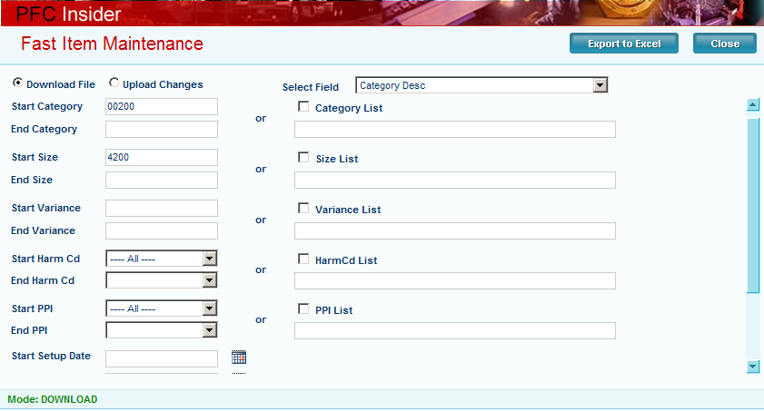

The only thing that is truly required is to select the field to maintain (I selected the category description). Please note that the larger the range selection is, the longer it will take the system to download (and upload) the information (I selected all category 00200 with size 4200).

Clicking the Export To Excel button opens the export window and the user should encounter the File Download dialogue. Notice that the program creates a unique file name based on the program, user ID & user name plus the field being maintained. Users should save the file to their own My Documents location to access it for maintenance and upload.

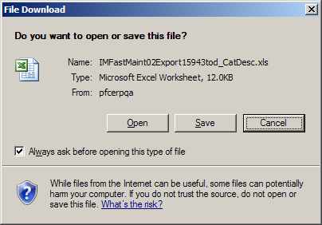
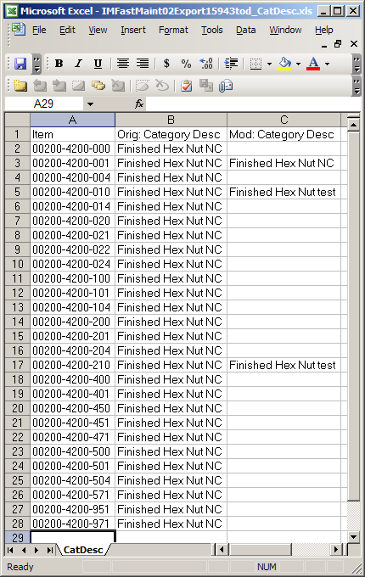
The downloaded file will look like this. Notice the name of the worksheet tab is “CatDesc” in this example. This is important! The worksheet tab name will ALWAYS reflect the name of the field being maintained. This is REQUIRED for the program to work properly. Other than that, this is a standard Excel worksheet. Users may sort the data or remove rows normally.

Notice the 3 changes that I made in column ‘C’. When I upload this file for processing only the 010 & 210 items will be updated. The program filters out all rows where column ‘C’ is empty or where columns ‘B’ and ‘C’ are equal.

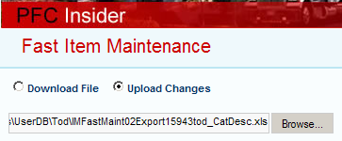
Once the changes are entered into the spreadsheet and saved, the user must upload the changes. The program uses the standard Windows browse function to allow the user to locate and choose a file.

Once the file has been selected, the user clicks the Submit button and the file is uploaded for processing (see below for technical details).

If there are exceptions encountered during the update, they will be emailed to the user; otherwise, the user will receive a success message from the process.
Upload process technical details (this upload is executed inside the webform)
The program loads all the data from the spreadsheet into a temporary SQL table. This step includes all rows; even the ones that have no changes. Once the temporary table is loaded, the update procedure is executed. The update procedure requires the name of the temporary table, the name of the field being updated and the user name. All of this information is sent by the program interface to the update procedure.

Update procedure technical details (this procedure is called by the web form)
The update procedure (pIMUpdFastMaint) accepts the name of the temporary table, the field name and the user name and processes the updates accordingly.

- INSERT all modified data FROM the temporary table INTO table IMFastMaint

The 1st step in the stored procedure filters out all data where the ‘Mod’ (or NewData) column is empty or where the ‘Orig’ and ‘Mod’ columns are equal. This assures that only records with modified data are inserted into IMFastMaint for processing.

- Pre-Processing Data Validation

Next begins the pre-processing validation which is very field dependent.

- If the update will affect the ItemUM table then store the ItemUMDivisor list.
--CREATE #tItemUMDivisor for fields that update ItemUM
IF (@FieldName = 'Wght' OR @FieldName = 'PCLBFTInd' OR
@FieldName = 'SellStkUM' OR @FieldName = 'SellUM' OR
@FieldName = 'CostPurUM' or @FieldName = 'SuperUM')

- There are separate validations dependent on the type of field being updated.
--Validate Numeric Data
IF (@FieldName = 'ListPrice' OR @FieldName = 'HundredWght' OR
@FieldName = 'Wght' OR @FieldName = 'PcsPerPallet')
- Any records found containing non-numeric ‘NewData’ are flagged for exception and will not be processed.
- Convert the NewData column to NumericData column
NumericData = CAST(isnull(NewData,'0') as DECIMAL(18,6))
- None of these fields will allow negative values; so, any negatives found in the NumericData column are flagged for exception and will not be processed.
- 'HundredWght' and 'Wght' cannot be zero. Zeros are flagged for exception and will not be processed.
- When the user chooses to update the Super UOM Qty, what it really affects in the data is the 'PcsPerPallet' field; therefore, NumericData is converted accordingly:
NumericData = NumericData * IM.SellStkUMQty

--Validate Check Box Data
IF (@FieldName = 'WebEnabledInd' OR @FieldName = 'CertRequiredInd' OR
@FieldName = 'HazMatInd' OR @FieldName = 'QualityInd' OR
@FieldName = 'PalPtnrInd')
- The first character of the NewData is validated to contain ‘Y’ or ‘N’ or else the records are flagged for exception and will not be processed.
- If the NewData indicates a ‘Y’ then the NumericData will be set = 1 (true); otherwise, it will be set = 0 (false).
--Validate against ListMaster/ListDetail
IF (@FieldName = 'PPICode') SET @ListName = 'ItemPPICd'
IF (@FieldName = 'PCLBFTInd') SET @ListName = 'ItemCalcUOM'
IF (@FieldName = 'SellStkUM') SET @ListName = 'UMName' --BaseUM
IF (@FieldName = 'SellUM') SET @ListName = 'SellPurUOM' --SellUM
IF (@FieldName = 'CostPurUM') SET @ListName = 'SellPurUOM' --PurchUM
IF (@FieldName = 'SuperUM') SET @ListName = 'SuperEquivUOM'

IF (@FieldName = 'Finish') --Validate against CatalogPlating table

IF (@FieldName = 'CustNo')
--Zero pad Customer Number
--Validate against CustomerMaster table

IF (@FieldName = 'BoxSize')
--Zero pad BoxSize (Routing No)
--Validate against ItemMaster table WHERE ItemStat=M

IF (@FieldName = 'Tariff') --Harmonizing Code
--Validate against TABLES table (GERTARIFF)

--Validate Alpha fields for truncation
IF (@FieldName = 'CatDesc') SET @MaxLen = 50
IF (@FieldName = 'ItemSize') SET @MaxLen = 20
IF (@FieldName = 'DiameterDesc') SET @MaxLen = 15
IF (@FieldName = 'LengthDesc') SET @MaxLen = 15
- Any records found to exceed their @MaxLen will be flagged with an exception but will still be processed. The data will be truncated and the exception will be reported.
- An additional exception is created if the 'CatDesc' exceeds 26 characters. This causes truncation in the building of the full ItemDesc field.

- Primary Updates

With pre-processing complete, a cursor is created for all the remaining records in the update set that have not been flagged as an exception to be skipped (the cursor allows us to step through each individual record in the data set; and we only have to step through the valid ones).
[Also note that the creation of the cursor is dependent on whether the
NewData column or the NumericData column is used for the update]

As each individual record is processed, the program will check/create a SoftLock for the item. If the item is found to be locked by another user, an exception is created and the record update is skipped, continuing with the next record in the cursor.

When the item is not locked by another user, the SoftLock is created and the primary ItemMaster field is updated based on the NewData or NumericData for the specific item in the cursor. This handles the main ItemMaster update for this specific ItemNo. Next begins the post-processing where any dependent data is updated (once again this is very field dependent; only now it is processing individual items as it steps through the cursor).
- Post-Processing dependent data for each update
--Build the full ItemDesc field
IF (@FieldName = 'CatDesc' OR @FieldName = 'ItemSize' OR
@FieldName = 'Finish')
--UPDATE ItemDesc = ItemSize + CatDesc + Finish

IF (@FieldName = 'BoxSize')
--UPDATE GrossWght from Routing/BoxSize adder

IF (@FieldName = 'HundredWght')
IF (@PCLBFTInd = 'LB')
--UPDATE PC Record in ItemUM
ELSE
--UPDATE Net & Gross Wght
--UPDATE LB Record in ItemUM

IF (@FieldName = 'Wght') --NetWght
--Update LB record in ItemUM (PC/LB/FT Item)
IF (@PCLBFTInd = 'LB')
--UPDATE Base Qty, PcsPerPallet & Gross Wght
--UPDATE PC Record in ItemUM
--Recalc UOMs using updated Base Qty & #tItemUMDivisor
ELSE
--UPDATE Hundred Wght & Gross Wght

IF (@FieldName = 'PCLBFTInd' OR @FieldName = 'SellStkUM' OR
@FieldName = 'SellUM' OR @FieldName = 'CostPurUM' OR
@FieldName = 'SuperUM')
--Make sure the ItemUM record exists; If not, create it
IF (@FieldName = 'PCLBFTInd')
--UPDATE SellStkUMQty & PcsPerPallet

IF (@FieldName = 'PcsPerPallet')
--UPDATE Super UOM Qty in ItemUM

With post-processing complete, the CompleteDt & CompleteID are set, flagging the update record as complete. The SoftLock is removed and the next item in the cursor is processed.

Here is the list of valid Fast Maintenance fields that comes from the IMFastFields list.

FieldName | Desc |  | FieldName | Desc
CatDesc | Category Desc |  | QualityInd | FQA Item
ItemSize | Size Desc |  | PalPtnrInd | Pallet Partner
Finish | Plating |  | ListPrice | List Price
DiameterDesc | Catalog Diameter |  | HundredWght | Wght/100 pcs
LengthDesc | Catalog Length |  | Wght | Net Wght
CustNo | Customer No |  | PCLBFTInd | PC / LB / FT
BoxSize | Routing No |  | SellStkUM | Base UOM
PPICode | PPI Code |  | SellUM | Sell UOM
Tariff | Harmonizing Code |  | CostPurUM | Purch UOM
WebEnabledInd | Web Enabled |  | SuperUM | Super UOM
CertRequiredInd | Cert Item |  | PcsPerPallet | Super UOM Qty
HazMatInd | Hazardous Materials

